**import** numpy **as** np  
**import** cv2  
**import** math  
**from** matplotlib **import** pyplot **as** plt  
**import** cv2.xfeatures2d  
**import** scipy

1. Up-sampling

**def** linear_interpolation(img, size):  
 shape = img.shape  
 result = np.ones((int(shape[0]), int(shape[1] * size), shape[2]))  
  
 **for** i **in** range(shape[0]):  
 **for** j **in** range(shape[1] * size):  
 **if** j % size == 0:  
 result[i][j] = img[int(i)][int(j / size)]  
 **else**:  
 **if** math.ceil(i) < shape[0] **and** math.ceil(j / size) < shape[1]:  
 result[i][j] = ((math.ceil(j / size) - j / size) / (math.ceil(j / size) - math.floor(j / size))) * \  
 img[i][math.floor(j / size)] + ((j / size - math.floor(j / size)) / (  
 math.ceil(j / size) - math.floor(j / size))) * img[i][math.ceil(j / size)]  
 **else**:  
 result[i][j] = img[i][math.floor(j / size)]  
 shape = result.shape  
 result1 = np.ones((int(shape[0] * size), int(shape[1]), shape[2]))  
 **for** i **in** range(shape[0] * size):  
 **for** j **in** range(shape[1]):  
 **if** i % size == 0:  
 result1[i][j] = result[int(i / size)][j]  
 **else**:  
 **if** math.ceil(i / size) < shape[0] **and** math.ceil(j) < shape[1]:  
  
 result1[i][j] = ((math.ceil(i / size) - i / size) / (math.ceil(i / size) - math.floor(i / size))) * \  
 result[math.floor(i / size)][j] + ((i / size - math.floor(i / size)) / (  
 math.ceil(i / size) - math.floor(i / size))) * result[math.ceil(i / size)][j]  
 **else**:  
 result1[i][j] = result[math.floor(i / size)][j]  
  
 **return** result1

image = cv2.imread(**"bee.jpg"**)  
image = image.astype(np.float32) / 255  
image1 = cv2.cvtColor(image, cv2.COLOR_BGR2RGB)  
result = linear_interpolation(image1, 4)  
result = np.round(result * 255).astype(np.uint8)  
plt.imshow(result)  
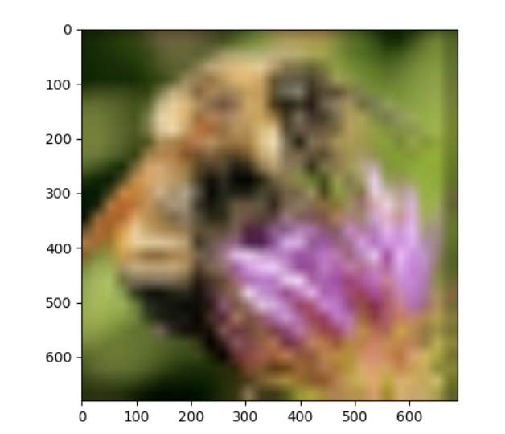plt.show()

This is a 1D filter applied twice. I think we can do the operation with a 2D filter. The filter is a Bilinear Interpolation filter.



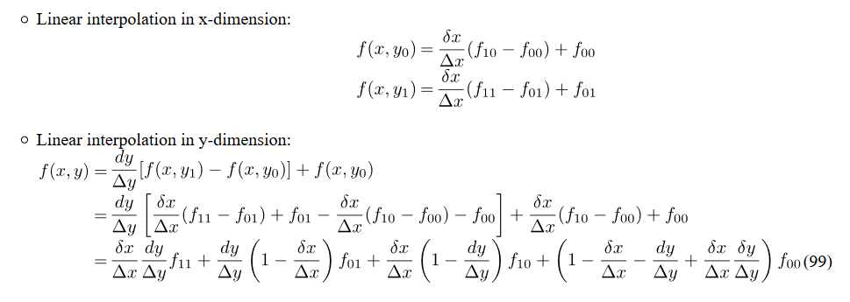

I found this algorithm for bilinear interpolation, but I could not implement it.

1. Interest point detection

**def** corner(img, a, key):  
 blur = cv2.GaussianBlur(img, (5, 5), 7)  
 Ix = cv2.Sobel(blur, cv2.CV_64F, 1, 0, ksize=5)  
 Iy = cv2.Sobel(blur, cv2.CV_64F, 0, 1, ksize=5)  
 IxIy = np.multiply(Ix, Iy)  
 Ix2 = np.multiply(Ix, Ix)  
 Iy2 = np.multiply(Iy, Iy)  
 Ix2_blur = cv2.GaussianBlur(Ix2, (7, 7), 10)  
 Iy2_blur = cv2.GaussianBlur(Iy2, (7, 7), 10)  
 IxIy_blur = cv2.GaussianBlur(IxIy, (7, 7), 10)  
 det = np.multiply(Ix2_blur, Iy2_blur) - np.multiply(IxIy_blur, IxIy_blur)  
 trace = Ix2_blur + Iy2_blur  
 **if** key == **"harris"**:  
 R = det - a * np.multiply(trace, trace)  
 **elif** key == **"brown"**:  
 **with** np.errstate(divide=**'ignore'**, invalid=**'ignore'**):  
 R = det / trace  
 **return** R

image = cv2.imread(**"building.jpg"**)  
image = image.astype(np.float32) / 255  
image1 = cv2.cvtColor(image, cv2.COLOR_BGR2RGB)

result = corner(image1, 0.05, **"harris"**)  
result1 = corner(image1, 0.05, **"brown"**)  
result = np.round(result * 255).astype(np.uint8)  
result1 = np.round(result1 * 255).astype(np.uint8)

plt.imshow(result)  
plt.show()  
plt.imshow(result1)  
plt.show()

Output:

harris:

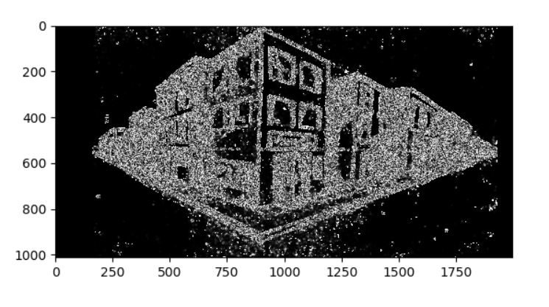

brown:

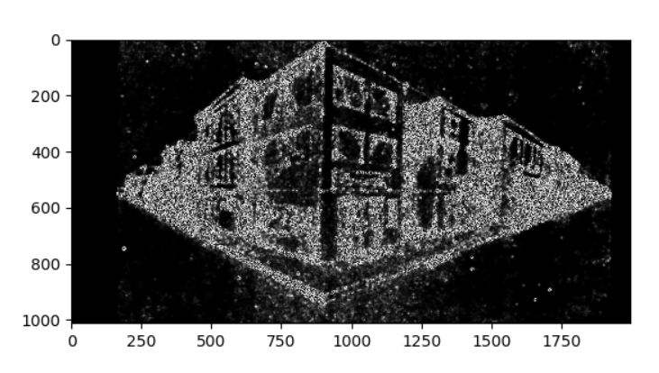

For harris detector, you can tone the strength of the detector by changing alpha, for brown you cannot.

I think there is a way to detect corners without using determinant and trace, if we use eigenvalues instead.

**def** corner_eigen(img):  
 eig = cv2.cornerEigenValsAndVecs(img, 7, 7)  
 result = np.empty(img.shape, dtype=np.float32)  
 **for** i **in** range(img.shape[0]):  
 **for** j **in** range(img.shape[1]):  
 lambda_1 = eig[i, j, 0]  
 lambda_2 = eig[i, j, 1]  
 result[i, j] = lambda_1 * lambda_2 - 0.05 * pow((lambda_1 + lambda_2), 2)  
 **return** result

image1 = cv2.imread(**"building.jpg"**, cv2.IMREAD_GRAYSCALE).astype(np.float32)

result = corner_eigen(image1)result = np.round(result * 255).astype(np.uint8)  
plt.imshow(result)  
plt.show()

Output:

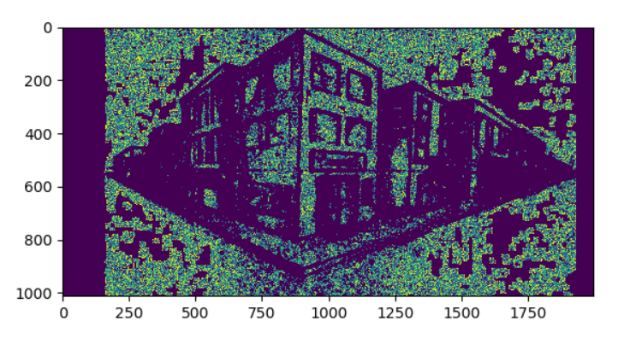



Normal:

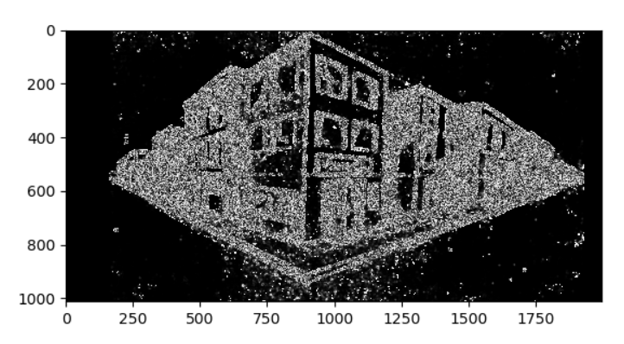

Rotated:

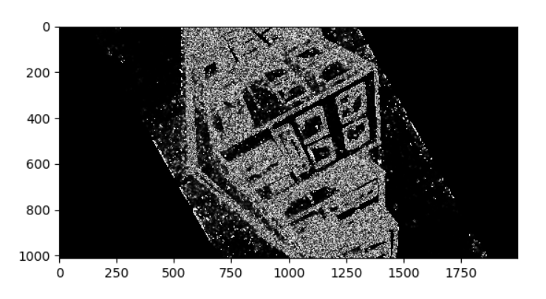

The corners all rotated by the same degree because harris corner detector is rotation invariant.



**def** patch_view(img, patch_h, patch_w):  
 h, w = np.array(img.shape) - np.array([patch_h, patch_w]) + 1  
 **return** np.lib.stride_tricks.as_strided(np.ascontiguousarray(img), shape=(h, w, patch_h, patch_w),  
 strides=img.strides + img.strides, writeable=**False**)  
  
  
**def** suppression(img, neighbours):  
 img_pad = np.pad(img, ((1, 1), (1, 1)), mode=**'constant'**, constant_values=0)  
 neighbours_pad = []  
 **for** item **in** neighbours:  
 neighbours_pad.append(np.pad(item, ((1, 1), (1, 1)), mode=**'constant'**, constant_values=0))  
  
 *# img_patches = skl.extract_patches_2d(img_pad, (3, 3), min(h,w))* img_patches = patch_view(img_pad, 3, 3)  
 neighbours_patches = []  
 **for** item **in** neighbours_pad:  
 neighbours_patches.append(patch_view(item, 3, 3))  
  
 patch_max = np.amax(img_patches, axis=(2, 3))  
  
 neighbours_patches_maxes = []  
 **for** item **in** neighbours_patches:  
 neighbours_patches_maxes.append(np.amax(item, axis=(2, 3)))  
 all_max = np.amax(np.dstack([patch_max] + neighbours_patches_maxes), axis=2)  
  
 is_cur_max = np.equal(img, all_max)  
  
 **return** img * is_cur_max  
  
  
**def** find_max(img, length, sigma):  
 scale = 2 ** (1 / length)  
 lapace = []  
 blur = []  
 **for** i **in** range(length):  
 blur_width = sigma * (scale ** i)  
 lapace.append(cv2.GaussianBlur(img, (5, 5), sigma))  
 blur.append(blur_width)  
  
 counter = 0  
 **for** item **in** lapace:  
 lap = np.abs(cv2.Laplacian(item, ddepth=cv2.CV_32F, ksize=5, scale=1))   
 lapace[counter] = lap  
 counter += 1  
 suppressed = [suppression(lapace[0], [lapace[1]])]  
 **for** i **in** range(len(lapace) - 2):  
 (down, cur, up) = lapace[i:i + 3]  
 suppressed += ([suppression(cur, [down, up])])  
 suppressed += ([suppression(lapace[-1], [lapace[-2]])])  
  
 stacked = np.dstack(suppressed)  
 max_id = np.argmax(stacked, axis=2)  
 max_item = np.amax(stacked, axis=2)  
 blur = np.array(blur)  
 corr_blur = blur[max_id]  
  
 max_coords = np.nonzero(max_item)  
 max_blur = corr_blur[max_coords]  
 responses = max_item[max_coords]  
 **return** np.array([responses, *max_coords, max_blur]).transpose()  
  
  
**def** SIFT(img, length, sigma, threshold):  
 result = np.dstack([np.copy(img)] * 3)  
 shortest_side = min(img.shape[0], img.shape[1])  
 reductions = int(np.log2(shortest_side)) - 1  
 cur_image = img  
 pyramids = []  
  
 **for** i **in** range(reductions):  
 scale = 2 ** i  
 pyramids.append([cur_image, scale])  
 cur_image = cv2.pyrDown(cur_image)  
  
 max = []  
  
 **for** img, scale **in** pyramids:  
 oct_max = find_max(img, length, sigma)  
 oct_max[:, 1:] *= scale  
 max += [oct_max]  
 max = np.concatenate(max)  
 threshold1 = np.percentile(max[:, 0], threshold)  
 **for** (response, y, x, blur_width) **in** max:  
 **if** response > threshold1:  
 radius = blur_width * (2 ** 0.5)  
 cv2.circle(result, (int(x), int(y)), int(radius), (0, 255, 0), 2)  
  
 **return** result

image1 = cv2.imread(**"building.jpg"**, cv2.IMREAD_GRAYSCALE).astype(np.float32)

result = SIFT(image1, 5, 9, 98)  
plt.imshow(result)  
plt.show()

Output:

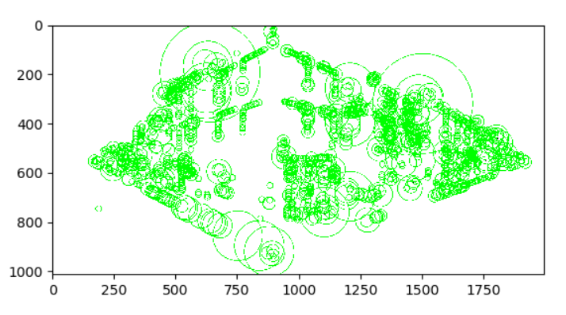



speeded up robust features (SURF)

Inspired by SIFT, but is faster. SURF uses an integer approximation of the determinant of Hessian blob detector, its feature descriptor is based on the sum of the Haar wavelet response around the point of interest.

Steps:

* + 1. Feature Extraction
       1. Uses a basic Hessian matrix approximation on the image
       2. Filter with gaussian kernel to adapt to different scale
       3. Get the determinant of the Hessian matrix by using box filter to approximate gaussian second derivative.
       4. Analyze the scale space by up-scaling the filter size
       5. Non-maximum suppression
    2. Feature Description
       1. Calculate the Haar-wavelet responses in x and y-direction in a radius of 6s
       2. Using the vertical and horizontal wavelet responses to get the orientation with the largest sum value, this is the main orientation
       3. Extract the descriptor

1. Laplacian of Gaussian
2. SIFT Matching (using OpenCV SIFT implimentation)

**def** SIFT_opencv(img):  
 sift = cv2.xfeatures2d.SIFT_create()  
 kp, des = sift.detectAndCompute(img, **None**)  
 result = cv2.drawKeypoints(img, kp, **None**)  
 **return** [result, kp, des]

sample1 = cv2.imread(**"sample1.jpg"**, cv2.IMREAD_GRAYSCALE)  
sample2 = cv2.imread(**"sample2.jpg"**, cv2.IMREAD_GRAYSCALE)

result = SIFT_opencv(sample1)  
result1 = SIFT_opencv(sample2)

plt.imshow(result[0])  
plt.show()  
plt.imshow(result1[0])  
plt.show()

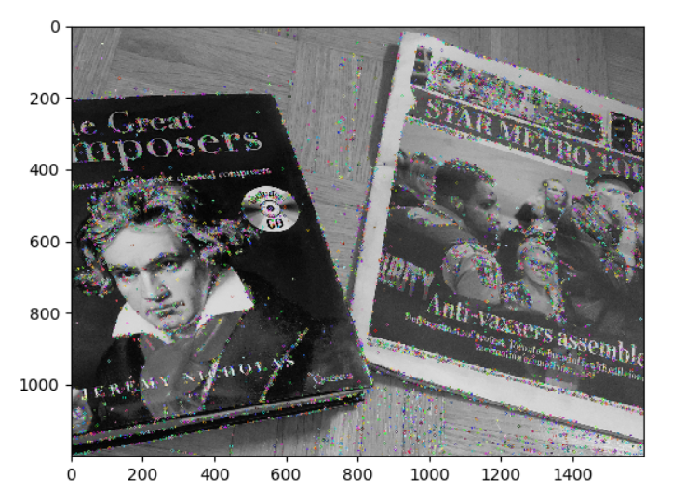 Output:

* 1. 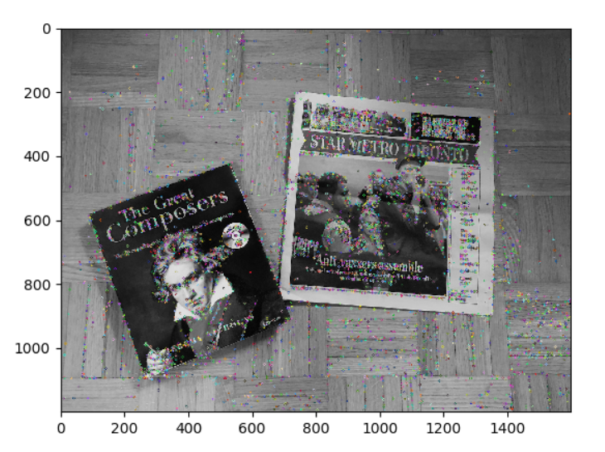

**def** SIFT_matching(img1, img2, threshold):  
 **if** img1[2] **is None or** len(img1[2]) == 0 **or** img2[2] **is None or** len(img2[2]) == 0:  
 **return** cv2.drawMatches(img1[0], img1[1], img2[0], img2[1], [], img2[0], flags=2)

*# it is possible that the following step might run out of space, if so, need more memory available*  
 euclidean = scipy.spatial.distance.cdist(img1[2], img2[2], metric=**'euclidean'**)  
 sorted1 = np.argsort(euclidean, axis=1)  
 closest, closest1 = sorted1[:, 0], sorted1[:, 1]  
 left_id = np.arange(img1[2].shape[0])  
 dist_ratios = euclidean[left_id, closest] / euclidean[left_id, closest1]  
 suppressed = dist_ratios * (dist_ratios < threshold)  
 left_id = np.nonzero(suppressed)[0]  
 right_id = closest[left_id]  
 pairs = np.stack((left_id, right_id)).transpose()  
 pair_dists = euclidean[pairs[:, 0], pairs[:, 1]]  
 sorted_dist_id = np.argsort(pair_dists)  
 sorted_pairs = pairs[sorted_dist_id]  
 sorted_dists = pair_dists[sorted_dist_id].reshape((sorted_pairs.shape[0], 1))  
  
 matches = []  
 print(**"Best 10 values: "**)  
 **for** i **in** range(10):  
 print(**"Pairs: {}, dist: {}"**.format(sorted_pairs[-i], sorted_dists[-i]))  
 matches.append(cv2.DMatch(sorted_pairs[-i][0], sorted_pairs[-i][1], sorted_dists[-i]))  
 result = cv2.drawMatches(img1[0], img1[1], img2[0], img2[1], matches, img2[0], flags=2)  
 **return** result

sample1 = cv2.imread(**"sample1.jpg"**, cv2.IMREAD_GRAYSCALE)  
sample2 = cv2.imread(**"sample2.jpg"**, cv2.IMREAD_GRAYSCALE)

result = SIFT_opencv(sample1)  
result1 = SIFT_opencv(sample2)

result2 = SIFT_matching(result, result1, 0.8)

plt.imshow(result[0])  
plt.show()  
plt.imshow(result1[0])  
plt.show()  
plt.imshow(result2)  
plt.show()

Output:

Best 10 values:

Pairs: [5204 2234], dist: [29.71531592]

Pairs: [5249 8925], dist: [289.92930173]

Pairs: [5462 8906], dist: [286.95470026]

Pairs: [3255 5301], dist: [286.69670385]

Pairs: [3213 5800], dist: [280.25167261]

Pairs: [3348 5481], dist: [279.4548264]

Pairs: [2900 4441], dist: [276.50678111]

Pairs: [3624 5979], dist: [275.21264506]

Pairs: [3109 4952], dist: [274.58878346]

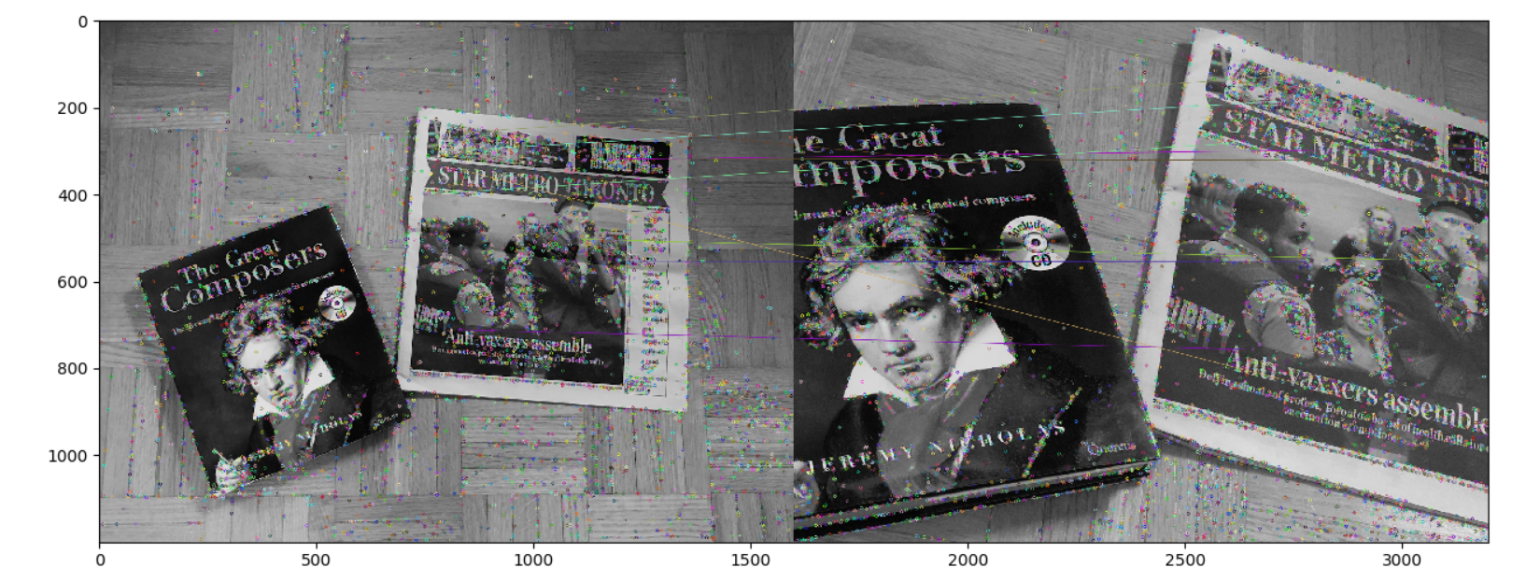Pairs: [5112 8811], dist: [273.9069185]

* 1. L1-norm:

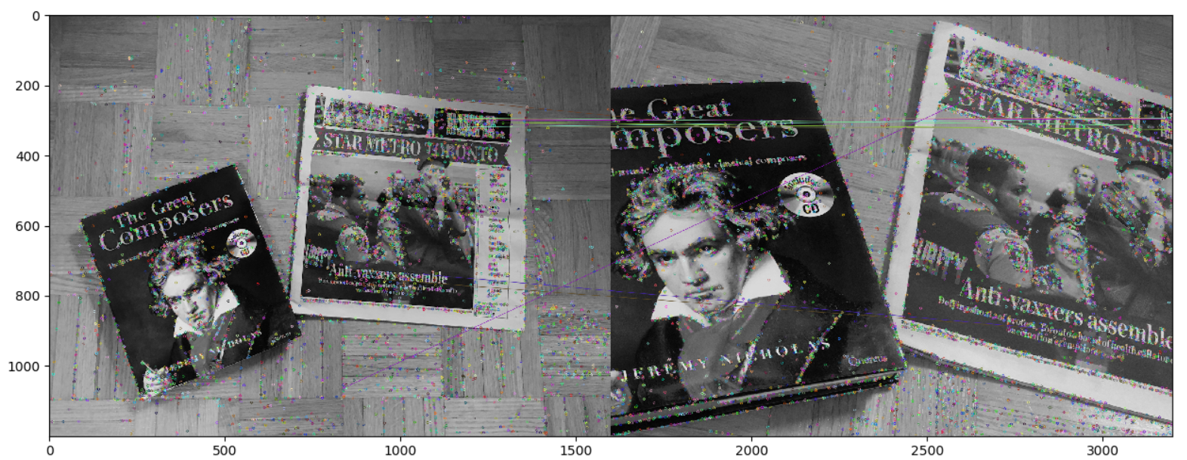Change metric=**'euclidean' to** metric=**'cityblock'**

Best 10 values:

Pairs: [5204 2234], dist: [223.]

Pairs: [4029 6837], dist: [2348.]

Pairs: [5617 8966], dist: [2338.]

Pairs: [5249 8925], dist: [2281.]

Pairs: [5247 8906], dist: [2265.]

Pairs: [5462 8906], dist: [2261.]

Pairs: [5684 8985], dist: [2248.]

Pairs: [4786 6837], dist: [2126.]

Pairs: [3202 5429], dist: [2092.]

Pairs: [6113 9028], dist: [2075.]

L3-norm:

Change metric=**'euclidean' to** metric=**'minkowski',** p**=3**

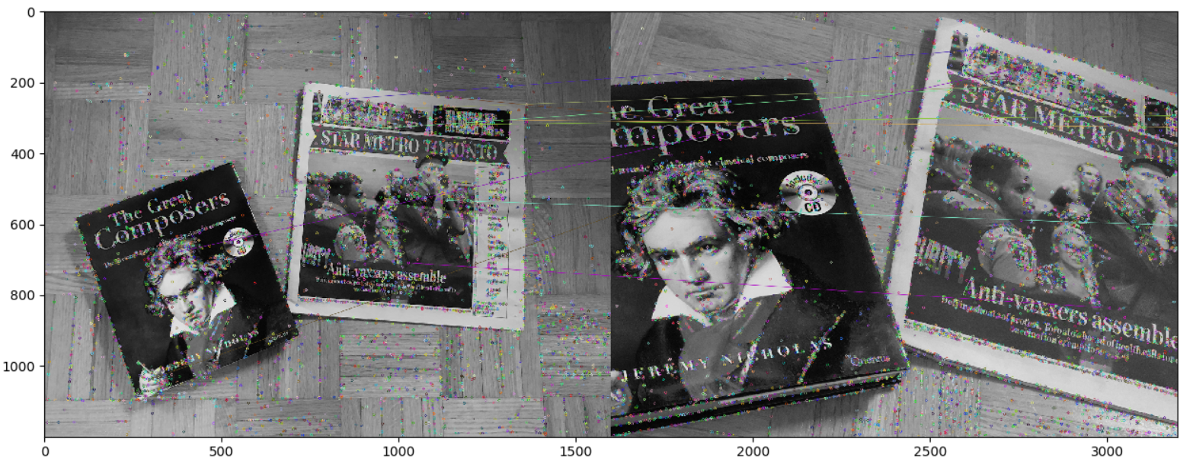

Best 10 values:

Pairs: [5204 2234], dist: [16.96764318]

Pairs: [ 705 1290], dist: [173.51916173]

Pairs: [4595 7910], dist: [163.20813489]

Pairs: [4228 7132], dist: [160.42394083]

Pairs: [6113 9028], dist: [160.07841209]

Pairs: [5220 9052], dist: [159.68275681]

Pairs: [2984 4686], dist: [158.69855733]

Pairs: [3033 4876], dist: [158.63301568]

Pairs: [ 641 5808], dist: [157.38816954]

Pairs: [5462 8906], dist: [156.9600423]



**def** add_noise(img):  
 noise = np.random.normal(0, 0.08, img.shape[:2])  
 result = img + noise  
 result = result.astype(np.uint8)  
 **return** result

sample1 = cv2.imread(**"sample1.jpg"**, cv2.IMREAD_GRAYSCALE)  
sample2 = cv2.imread(**"sample2.jpg"**, cv2.IMREAD_GRAYSCALE)

sample1 = cv2.normalize(sample1, sample1, 0, 1, cv2.NORM_MINMAX)  
sample2 = cv2.normalize(sample2, sample2, 0, 1, cv2.NORM_MINMAX)  
plt.imshow(sample1)  
plt.show()

plt.imshow(sample2)  
plt.show()

sample1 = add_noise(sample1)  
sample2 = add_noise(sample2)

plt.imshow(sample1)  
plt.show()  
plt.imshow(sample2)  
plt.show()

# opencv’s SIFT algorithm only produces entirely black image if the following step is # not performed

sample1 = np.round(sample1 * 255).astype(np.uint8)  
sample2 = np.round(sample2 * 255).astype(np.uint8)

result = SIFT_opencv(sample1)  
result1 = SIFT_opencv(sample2)

result2 = SIFT_matching(result, result1, 0.8)

plt.imshow(result2)  
plt.show()

output:

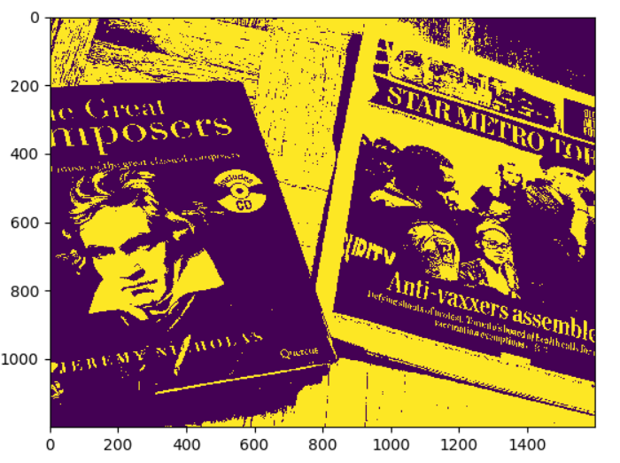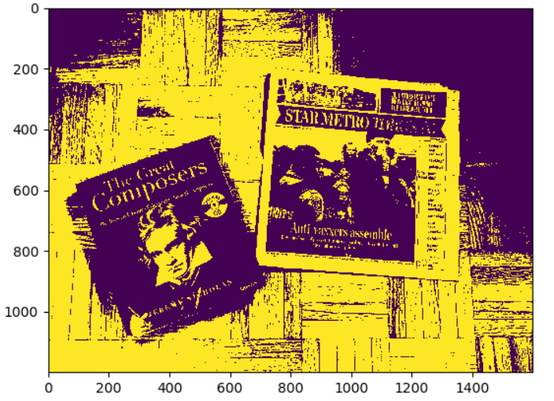normalized:

Added noise:

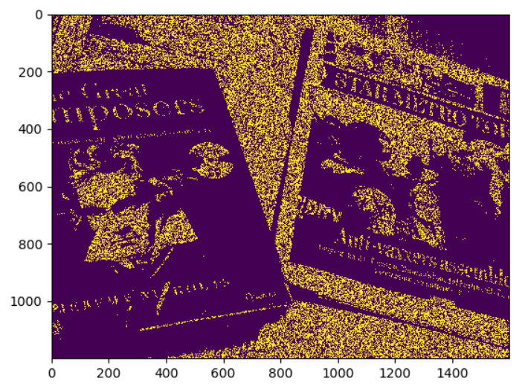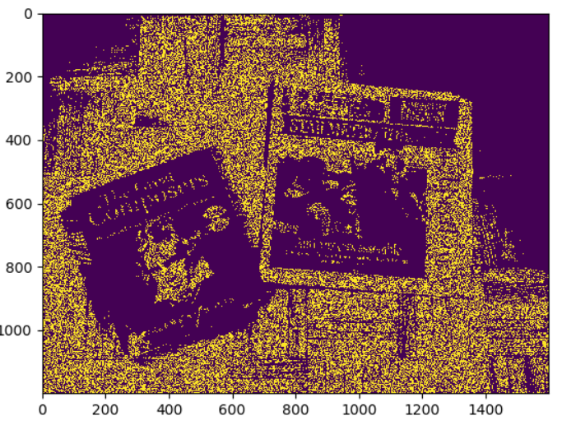

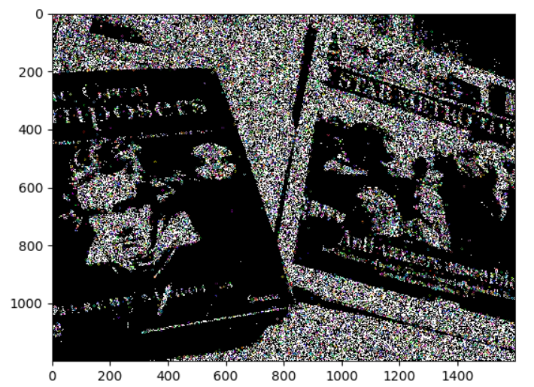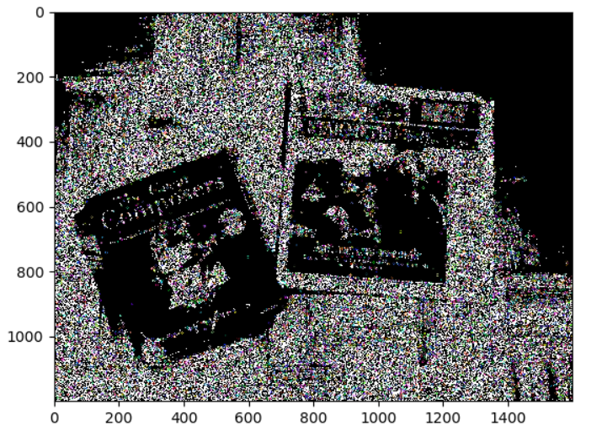After SIFT:

I could not run SIFT matching because it requires too much memory.

MemoryError: Unable to allocate array with shape (16728, 12463) and data type float64

The feature point detection detected too many noises as feature points. I hypothesize that if I were able to run the matching algorithm, the features would be matched very poorly due to the noises.



col1 = cv2.imread(**"colourSearch.png"**)  
col2 = cv2.imread(**"colourTemplate.png"**)

b, g, r = cv2.split(col1)  
b1, g1, r1 = cv2.split(col2)  
result = [SIFT_opencv(item) **for** item **in** [b, g, r]]  
result1 = [SIFT_opencv(item) **for** item **in** [b1, g1, r1]]  
  
result2 = [SIFT_matching(result[i], result1[i], 0.8) **for** i **in** range(3)]  
**for** i **in** range(3):  
 result2[i] = cv2.cvtColor(result2[i], cv2.COLOR_BGR2GRAY)  
result3 = cv2.merge(result2)  
  
plt.imshow(result3)  
plt.show()

Output:

Best 10 values:

Pairs: [19 13], dist: [21.09502311]

Pairs: [13 17], dist: [187.57931656]

Pairs: [3 6], dist: [184.49661244]

Pairs: [ 8 11], dist: [177.35557505]

Pairs: [ 7 10], dist: [172.58331321]

Pairs: [5 8], dist: [93.978721]

Pairs: [21 40], dist: [93.47192092]

Pairs: [25 38], dist: [75.41883054]

Pairs: [12 16], dist: [63.67102952]

Pairs: [20 39], dist: [62.8251542]

# a different channel

Best 10 values:

Pairs: [4 2], dist: [23.60084744]

Pairs: [20 5], dist: [318.55768708]

Pairs: [11 9], dist: [247.24077334]

Pairs: [12 10], dist: [211.26996947]

Pairs: [15 11], dist: [193.86851214]

Pairs: [23 19], dist: [193.82208337]

Pairs: [7 1], dist: [191.9479096]

Pairs: [29 31], dist: [183.50476833]

Pairs: [16 12], dist: [164.50227962]

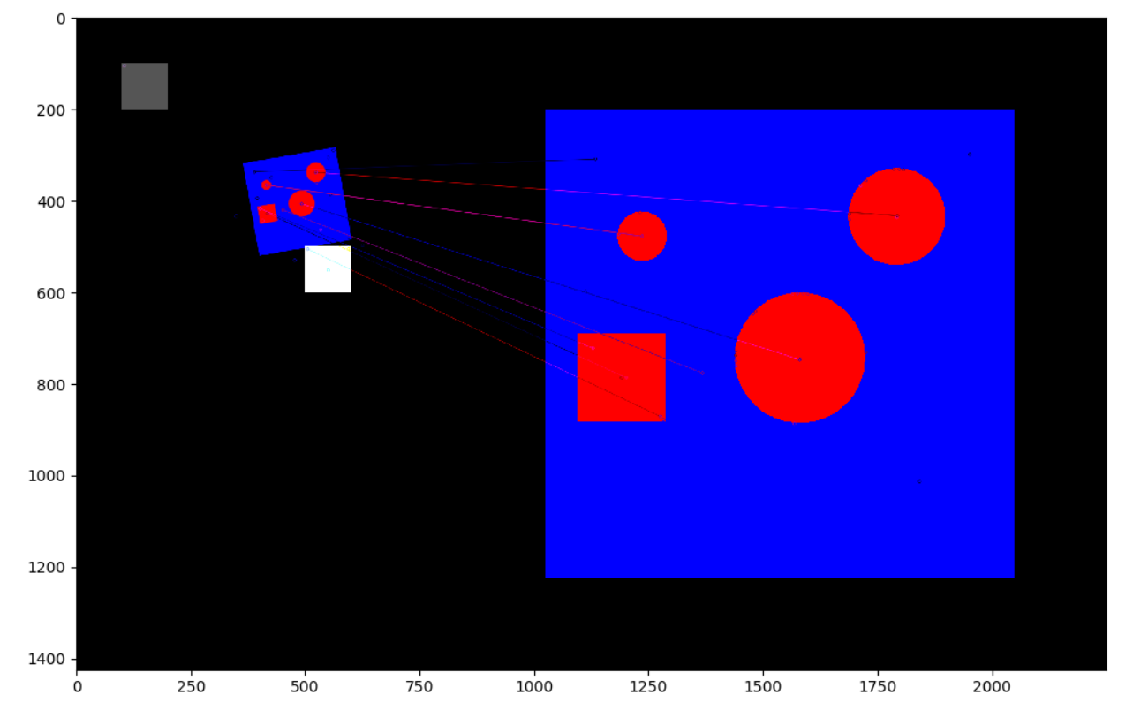Pairs: [30 29], dist: [159.68719423]

I separated the three channels and ran the SIFT + matching algorithm separately for each channel. Then I merged the 3 channels back together. One of the channels was empty, so it did not have any matches.